Ideation Phase
Brainstorm & Idea Prioritization Template

Date | 25 June 2026
Team ID
Project Name | House Rent
Maximum Marks | 4 Marks

Brainstorm & Idea Prioritization Template:
Brainstorm & Idea Prioritization: Our team conducted a brainstorming session to identify, discuss, and organize the key features required for the House Rent – House Rental Management System. We generated multiple ideas, grouped related functionalities, and prioritized them based on their impact, feasibility, and implementation effort. This process helped us focus on essential features such as user authentication, property management, property search and filtering, booking, owner approval, online payment, transaction history, responsive design, dark/light mode, and multiple property image uploads. By following a structured brainstorming and prioritization approach, we were able to define a clear development roadmap and build a practical, user-friendly, and efficient house rental management system.
Step-1: Team Gathering, Collaboration and Select the Problem Statement
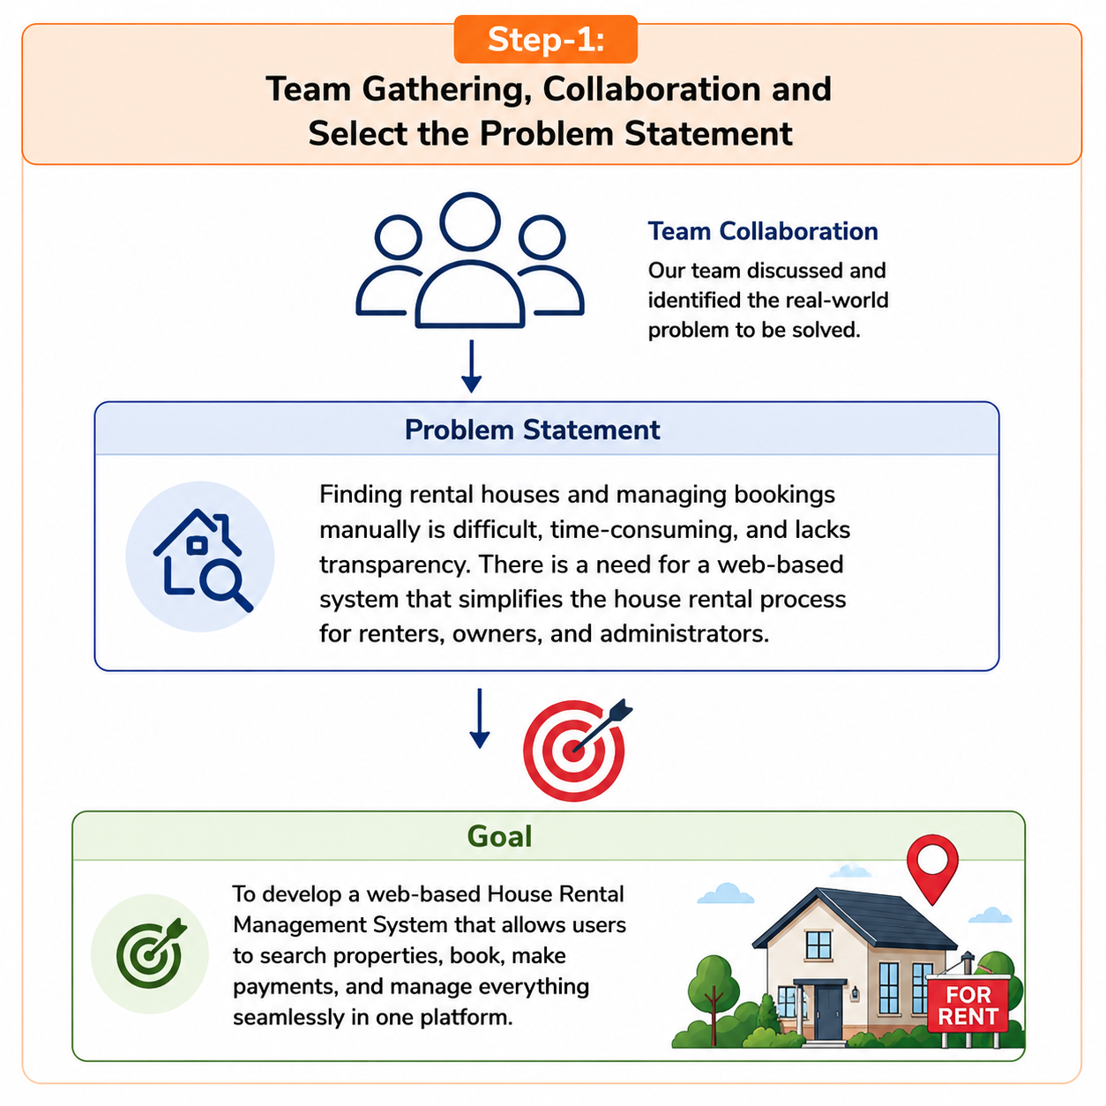

Step-2: Brainstorm, Idea Listing and Grouping
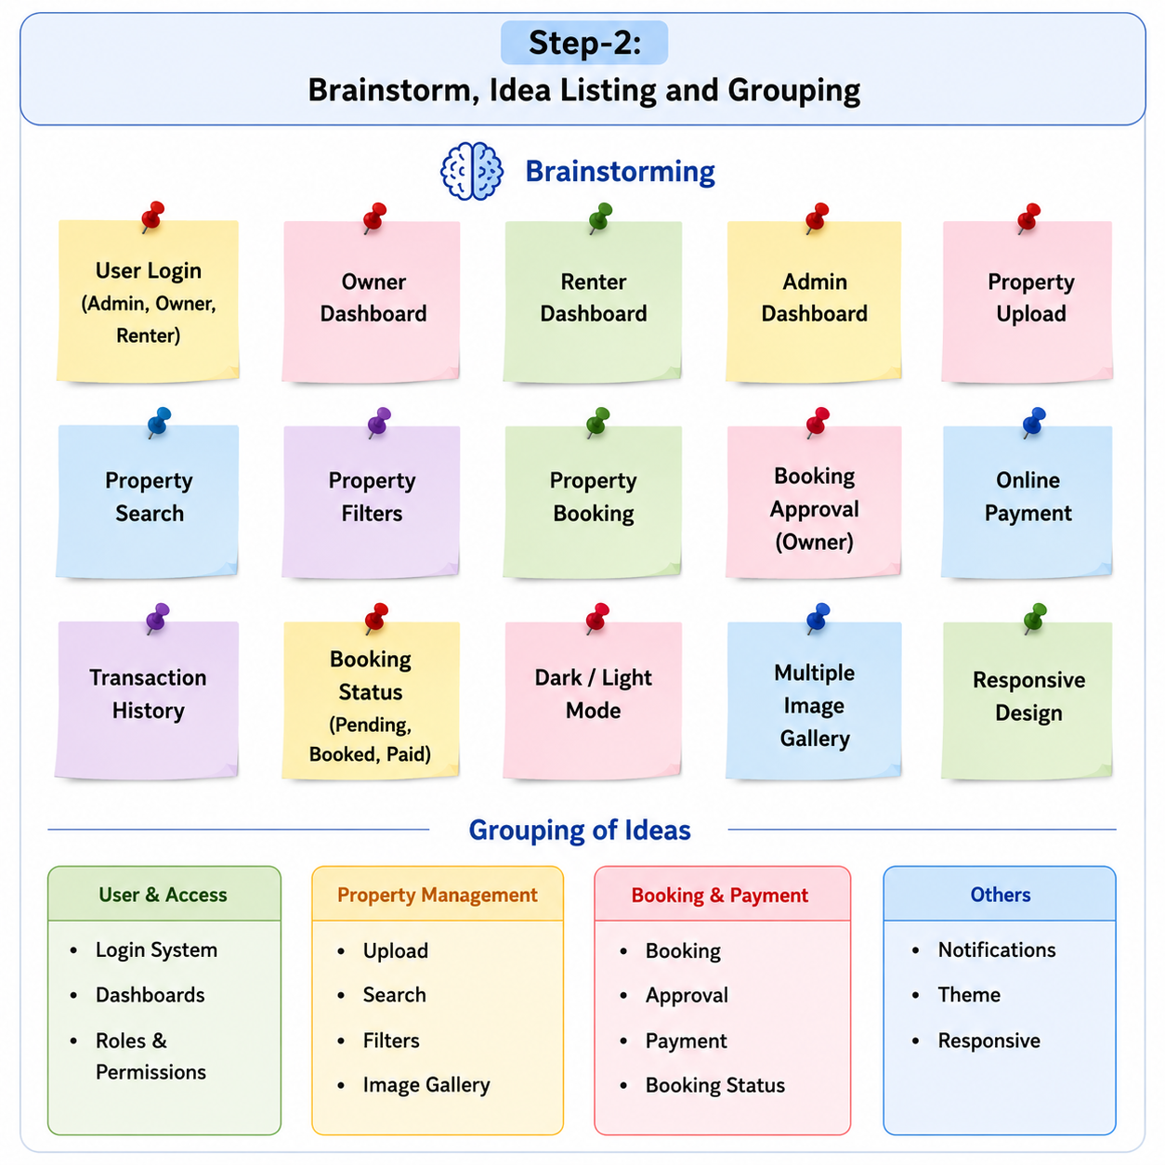
Step-3: Idea Prioritization
